**FE1 Happy Meal Case**

Daesun Im, Jaewook Jeong, jeonghun Lee

**Question 1. Value the convertible bond with FDM.**

Using Crank Nicolson method

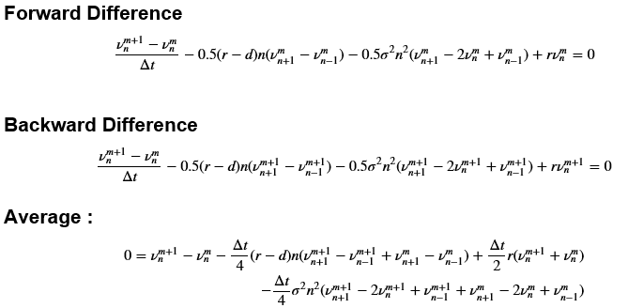

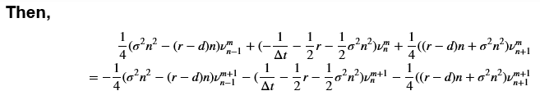

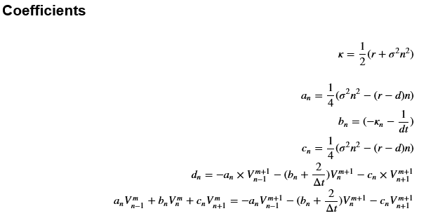

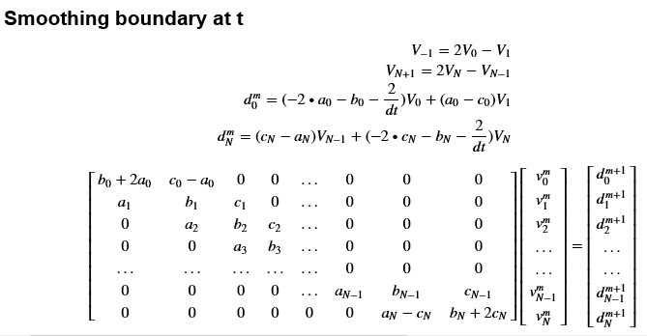

Variable Settings :

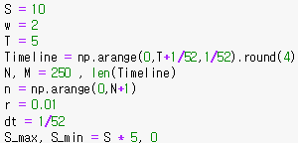 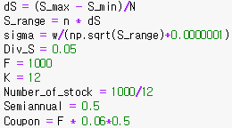

The Convertible Bond Price is following :

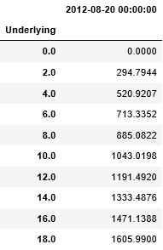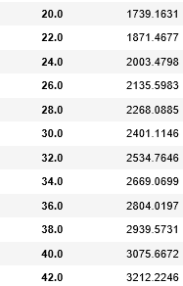

The Bond Price at August 20, 2012, is $1043 (Which is more than par value)

Compare between (S max = 50 , N = 250), ( S max = 100, N = 250) , (S max = 25, N = 100)

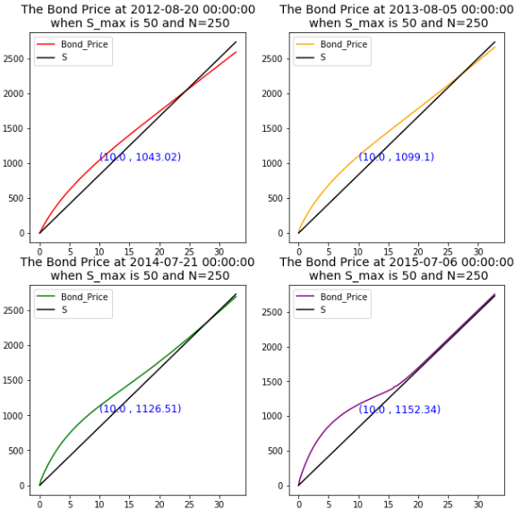

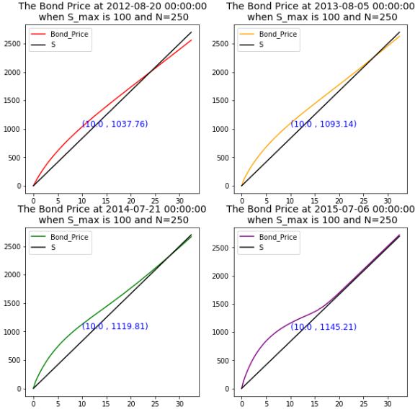

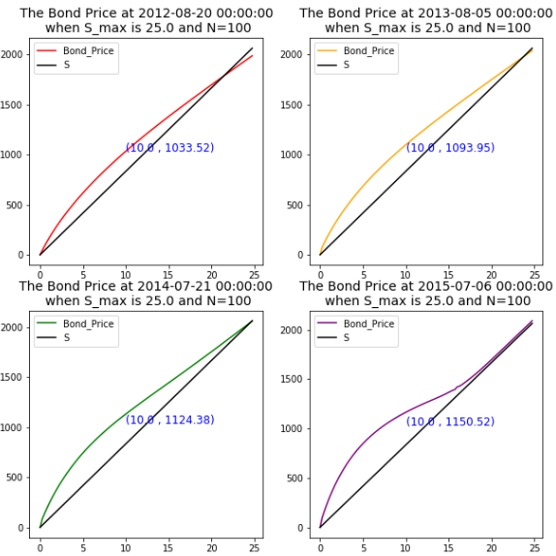

The Price This PDE is one factor stochastic model so there are many factors that are not reflected in the model. Examples of factors not reflected in the model are following

1. The model is unrealistic because the dynamics of asset value and leverage ratio are not reflected in the model.
2. Even though the share price is not zero, it would be difficult to expect a full repayment of principal and interest if the share price is significantly lower. If these effects are adjusted, prices will move in a lower direction.
3. Even if a company goes bankrupt, some reimbursement is possible by liquidating its assets. Thus, prices move in the direction of rising if the recovery is reflected.

**Question2. If y = 20%**

That’s True (The company would not have been able to sell the bonds for face value)

The interest rate on the loan of shares is the merit that occurs when the shares are held, not the call option. Therefore, the price of convertible bonds falls further.

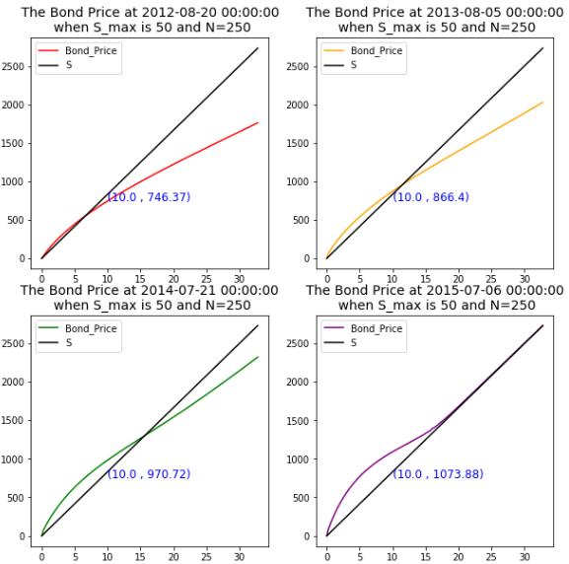

**Question3. The Excel File attached ( P&L_data.xlsx)** 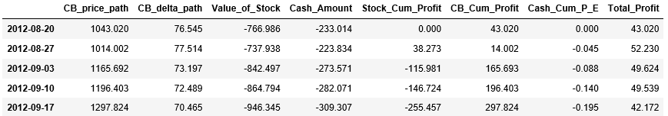

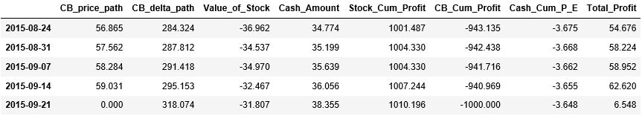

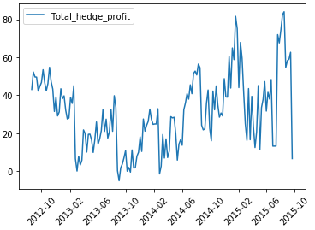

Number of Bond = 10,000

The hedge position P&L is $6.548 * 10,000 = $65,480

It is less than 430,000 {which is (1043-1000)*10,000}

This means that losses have occurred in the hedge process of derivatives.

The main reason for this hedge loss is the negative gamma of the bonds in most cases. As you can see from the picture above, the price of the bond is almost concavely determined by the stock price (Except for sections where stock prices are significantly high). Therefore, In most cases, to hedge the product, you have to hedge more than the delta of the product.